AI-DCIM — Technical Project Proposal
Status: Draft | Author: ASAL Technology | Date: July 2026 | Prepared For: Technical & Business Leadership
A brief note before the detail. We prepared this following DEMS documents based on competitors research. The plan is staged deliberately: you get a working monitoring platform, and revenue, well before the AI capabilities mature. If any assumption in Section 9 does not hold for your sites, please raise it early. Most affect the timeline more than the design.

Table of Contents
- Feature Scope
- Technical Architecture
- Deployment Options
- Team
- Development Plan
- Commitments & KPI Register
- Prerequisites & Client Dependencies
- Out of Scope
- Assumptions & Expectation-Setting

1. Feature Scope
We’ve grouped the platform into ten capability areas. Every feature carries a tag so its origin is clear:
- REBUILD — already in DEMS today; re-engineered on the new stack
- NEW — not in DEMS. Drawn from gaps in competitor products and from what operators regularly ask for
- AI — a machine-learning or LLM capability we have not seen offered comparably in the region
- CTRL — actively controls the hardware, rather than only monitoring it

1.1 Monitoring & Data Acquisition
This is the foundation, and the area where the client field experience counts most. Most of it already exists in DEMS; the work is re-engineering it onto a stack that can carry the AI layers later. The one genuinely new item, offline edge buffering, is also the one that matters most on sites with unreliable links.
Feature | Tag | Description
Multi-protocol edge acquisition | REBUILD | Collect from any device over Modbus TCP/RTU, SNMP v1/v2c/v3, BACnet, OPC-UA, DLT-645, IEC 61850, and proprietary protocols. No vendor lock-in.
UPS monitoring | REBUILD | Load percentage, input/output voltage & frequency, bypass status, runtime remaining, fault codes
Battery bank monitoring | REBUILD | Per-cell voltage, total voltage, charge/discharge current, temperature, state of charge, discharge history
HVDC / High-Voltage DC monitoring | REBUILD | Three-phase voltage, current, frequency, power factor, energy consumption, main breaker status
Power distribution monitoring | REBUILD | Per-circuit breaker status, AC/DC PDU parameters, branch circuit current, energy by zone
Precision AC / CRAC monitoring | REBUILD | Fan speed, water valve opening, supply/return water loop temps, compressor status, unit-level run hours
Temperature & humidity monitoring | REBUILD | Per-sensor readings organized by cabinet row and aisle (cold/hot), with threshold highlighting
Water leakage detection | REBUILD | Sensor status, location on floor plan, immediate alert on detection
Generator monitoring | NEW | Fuel level, runtime hours, last test date, output voltage/frequency, transfer status
ATS / Transfer switch monitoring | NEW | Source selection (utility/generator/UPS), transfer event log, last-test timestamp
Differential pressure monitoring | REBUILD | Under-floor and hot-aisle differential pressure; trend alerts for filter clogging
IT equipment monitoring | NEW | Server power draw, CPU/memory utilization via IPMI, iLO, or iDRAC; rack-level power summation
Smart meter integration | REBUILD | Utility feed metering, tariff-based energy cost tracking
CCTV integration | REBUILD | Live feed viewer, motion detection events, clip retrieval by alarm time
Device health status | REBUILD | Communication status, last-seen timestamp, data quality flag per device
Offline edge buffering | NEW | Edge stores-and-forwards telemetry during WAN outage with no data loss within the buffer’s retention window (sized per site; 7-day default); full replay on reconnect

1.2 Control & Automation
Monitoring tells you what happened; control lets you act on it. Everything tagged CTRL writes back to physical equipment, so it carries real operational risk. Every one of these actions runs behind a confirmation gate and an audit log. This is a clear step beyond what DEMS does today.
Feature | Tag | Description
PDU outlet-level control | NEW CTRL | Remote on/off/reboot per individual outlet on smart PDUs
AC setpoint remote adjustment | NEW CTRL | Push temperature setpoint changes to precision AC units from the platform
UPS bypass / transfer control | NEW CTRL | Manually initiate bypass or transfer mode on supported UPS units
Generator remote start/stop | NEW CTRL | Trigger generator test cycles or emergency starts remotely
ATS manual transfer | NEW CTRL | Force source transfer (utility ↔ generator) from the platform
Access control remote override | REBUILD CTRL | Lock/unlock cabinet doors and room access remotely, trigger emergency lockdown
Fan / cooling automation | NEW CTRL | Adjust fan speeds or water valve positions in response to thermal conditions
Lighting control | REBUILD CTRL | Zone-level lighting on/off scheduling and alarm-triggered activation
Automated remediation playbooks | NEW CTRL | Configurable event → action chains: “if UPS battery < 20%, shed non-critical PDU outlets”
Scheduled power cycling | NEW CTRL | Plan and schedule outlet power cycles for maintenance windows
Load shedding automation | NEW CTRL | Pre-defined priority tiers for automated load shedding during power events
Ventilation control | REBUILD CTRL | Trigger skylight/ventilation actuators on thermal or fire events
Control audit log | NEW | Immutable log of every control action: who, what, when, result

1.3 Visualization & Dashboards
Three audiences, three different needs. An executive wants a single figure that tells them whether to worry; an engineer wants the live detail behind it. The dashboards below are built around that split rather than forcing everyone through one view.
Feature | Tag | Description
Executive dashboard | NEW | Single-screen view: uptime, active alarms, PUE, energy cost, risk summary across all sites
Engineer dashboard | NEW | Live telemetry, topology, alarm queue, device status for a specific site or zone
Operator dashboard | REBUILD | Shift-ready view: current alarms, recent events, device quick-status
2D floor plan | REBUILD | Drag-and-drop floor map with equipment placed, live status overlays, alarm highlighting
Interactive 3D room view | REBUILD | Real-time 3D rendering of the facility; click any device for detail; alarm animations
Power topology diagram | REBUILD | Live single-line diagram from utility feed through ATS → switchgear → UPS → PDUs → racks
Cooling zone map | NEW | Overlay of cold/hot aisles, CRAC coverage zones, rack inlet temperatures as a heat map
Network topology diagram | REBUILD | Device connectivity map with communication status
Multi-site overview map | NEW | Geographic or list-based view of all client sites with per-site status rollup
Customizable dashboards | NEW | Drag-and-drop widget builder; users create their own views without developer involvement
Dark / light theme | REBUILD | Operator-preference theme selection
Mobile app (iOS & Android) | REBUILD | Real-time status, alarm acknowledgement, historical queries, remote control actions

1.4 Alarm & Event Management
Alarm handling is where operators either trust a system or learn to ignore it. The aim here is fewer, better alarms: correct severity, sensible grouping, and no floods during a maintenance window. The two AI-driven items at the bottom of the table build on this foundation once there is enough history to learn from.
Feature | Tag | Description
4-tier alarm severity | REBUILD | Informational / Normal / Critical / Emergency, with per-tier visual and audio indicators
Configurable alarm thresholds | REBUILD | Per-device and per-metric threshold bands with hysteresis to prevent flip-flopping
Alarm acknowledgement workflow | REBUILD | Acknowledge, add notes, assign to engineer; full audit trail
Alarm convergence | REBUILD | Parent-child suppression: upstream root cause is shown; downstream child alarms are grouped and hidden
SMS & email notifications | REBUILD | Per-alarm-type routing rules; scheduled notification windows (e.g., only page on-call outside business hours)
Push notifications | NEW | Mobile push for critical/emergency alarms
Alarm escalation chains | NEW | Auto-escalate unacknowledged alarms to next tier after configurable timeout
Maintenance window suppression | NEW | Pre-schedule maintenance windows; alarms during window are logged but not routed
Alarm history & audit | REBUILD | Full searchable history with acknowledgement and resolution records
AI-driven noise reduction | AI | ML correlation engine reduces alert volume by suppressing non-actionable derivative alarms; learns from engineer feedback
Anomaly-based alerting | AI | ML-detected anomalies trigger alerts before threshold breaches occur

1.5 Digital Twin & Capacity Management
This is what turns a monitoring tool into something that can reason about the facility. Modeling the power and cooling dependencies is not glamorous work, but it is the prerequisite for root-cause analysis, impact analysis, and any capacity planning you can actually defend to a client.
Feature | Tag | Description
Canonical asset registry | NEW | Every asset modeled with attributes: make, model, serial, firmware, U-position, install date, warranty expiry
Power-chain dependency graph | NEW | Full electrical dependency: utility → ATS → switchgear → UPS → PDU → individual outlets → racks. Queryable at any level.
Cooling-zone model | NEW | Maps every CRAC/InRow/chiller to the racks and zones it cools; links to live airflow data
Live twin binding | NEW | Every modeled asset is bound to its real-time telemetry; the twin reflects current physical state, not just design intent
Impact analysis | NEW | “If UPS-2 fails, what racks lose power?” — answered instantly from the dependency graph
Power capacity planning | NEW | Available vs. allocated vs. actual power per PDU, UPS, and site. Stranded capacity analysis.
Cooling capacity planning | NEW | Cooling headroom per zone; capacity-exhaustion warnings before racks are overloaded
Space / rack capacity | REBUILD | U-position utilization (idle / occupied / reserved / pre-allocated) with visual rack elevation view
What-if planning | NEW | Simulate adding X kW to zone Y; show impact on power and cooling headroom before any physical change
Decommissioning planning | NEW | Model asset removal and its downstream effects on capacity and dependency chains
Network port capacity | NEW | Track patch panel and switch port utilization; flag stranded ports

1.6 Asset & Operations Management
The day-to-day operational layer. None of it is technically difficult, but it is the part clients live in, and it is where a competitor with a tidy work-order and maintenance workflow can quietly win an account.
Feature | Tag | Description
U-position asset tracking | REBUILD | Rack elevation view with asset placement, idle/occupied/reserved status, bulk install/remove workflows
Equipment lifecycle management | NEW | Track purchase date, warranty, EOL date, maintenance history per asset
Spare parts management | REBUILD | Parts inventory, minimum stock alerts, vendor and lead time tracking
QR / barcode scanning | NEW | Scan an asset tag via mobile to pull up its full profile and history
Cable & connectivity documentation | NEW | Record port-to-port cable runs; visualize connectivity paths
Work order management | NEW | Create, assign, schedule, and close work orders; tie to alarms or assets; track SLA compliance
Preventive maintenance schedules | NEW | Calendar-based recurring maintenance tasks per asset class (e.g., battery load test every 6 months)
Round inspection workflows | REBUILD | Guided inspection checklists for on-site technicians; completed via mobile
Shift management | REBUILD | Shift handover reports automatically generated from events during the shift
Emergency drill management | REBUILD | Pre-defined drill sequences with step-by-step operator guidance
Contractor access management | NEW | Time-limited credentials and access zones for third-party technicians
SLA tracking | NEW | Track response and resolution times against defined service levels; dashboard and report

1.7 Energy Management
Energy is the line item a facility manager is measured on, which makes it the easiest place to demonstrate return. Live PUE and cost allocation are the near-term wins. The AI-driven PUE optimization in the last row is a Phase 5 capability, not a day-one one, and we are careful to present it that way.
Feature | Tag | Description
Live PUE calculation | NEW | Real-time PUE (Power Usage Effectiveness) per site and per zone
Energy consumption by zone / rack | REBUILD | Drill-down from site → zone → rack → outlet; kWh with time-series charts
Energy efficiency index | REBUILD | Composite efficiency score with trend and benchmark comparison
Carbon footprint reporting | NEW | CO₂-equivalent calculations based on energy consumption and regional grid factor
Cost allocation by tenant/department | NEW | Allocate energy costs to rack owners, business units, or client tenants
Tariff-based cost calculations | NEW | Apply time-of-use tariffs to energy data; show peak vs. off-peak cost breakdown
Energy budget tracking | NEW | Set monthly/annual energy budgets per site; alert on pacing
Thermal PUE optimization | AI | ML-driven cooling setpoint recommendations targeting minimum PUE while maintaining thermal safety

1.8 Security & Physical Access
For the Gulf market this is not optional. Government and banking clients will not proceed without OT/IT segregation, strict access control, and a complete audit trail, so we treat these as baseline requirements rather than features to upsell.
Feature | Tag | Description
Access control management | REBUILD | Standalone, cabinet locks, CACS, HTTP, and facial recognition controllers
Schedule-based access | REBUILD | Restrict entry/exit by time of day, day of week, or named schedule
Personnel & privilege management | REBUILD | Individual card permissions, privilege card synchronization, bulk assignment
Intrusion detection | REBUILD | Brute-force intrusion detection, door-held-open alerts, door-open timeout alerts
CCTV integration | REBUILD | Live view, alarm-triggered recording, clip export, camera health status
Security floor plan overlay | REBUILD | Real-time positions and statuses of doors, smoke detectors, water leak sensors, cameras on the floor plan
Fire & smoke detection | REBUILD | Sensor status, zone mapping, alarm routing to fire panel and operator
OT/IT network segregation | NEW | Dual-NIC edge gateway; OT network is never directly accessible from IT or cloud
Outbound-only mTLS tunnels | NEW | Zero inbound exposure of OT networks; all cloud communication is outbound-initiated and mutually authenticated
Immutable audit logs | NEW | All access and configuration changes written to an append-only log for compliance and forensics

1.9 AI Intelligence Layer
Expectation-setting: Every accuracy figure below is a target, not a guarantee, and is conditional on telemetry data quality and history. Models require ≥90 days of clean data to begin producing value and 6–12 months to reach full accuracy. See the consolidated targets and their conditions in Section 6 and the data-dependency assumptions in Section 9.
Feature | Tag | When Available | Description
Predictive maintenance | AI | Phase 4 | Anomaly detection + remaining-useful-life (RUL) models on UPS batteries, fans, compressors. Predicts failures 14+ days ahead.
Thermal intelligence | AI | Phase 4 | Hotspot prediction and cooling-imbalance detection using sensor arrays and the cooling-zone model
AC setpoint optimization | AI | Phase 5 | ML-driven cooling setpoint recommendations that reduce PUE while maintaining thermal safety margins
Load & capacity forecasting | AI | Phase 4 | Time-series forecasting of power and cooling load; capacity-exhaustion date projections
AI alarm noise reduction | AI | Phase 4 | Learned cross-device event correlation reduces actionable alert volume. Target: ≥50% at launch, improving toward 60%+ as the model accumulates feedback
Root Cause Analysis (RCA) | AI | Phase 4 | Causal traversal of the power/cooling dependency graph; probabilistic inference of failure origin
LLM alarm narratives | AI | Phase 5 | LLM generates a plain-language incident summary: what happened, what caused it, recommended next steps
Conversational assistant | AI | Phase 5 | RAG-based assistant grounded in the live digital twin: “Which rack is closest to thermal limit?”, “What caused the 2am alarm?”
Anomaly detection | AI | Phase 4 | Statistical anomaly detection on all time-series signals; flags deviations before threshold breaches
Model drift monitoring | AI | Phase 4 | Continuous monitoring of ML model performance; auto-retrain triggers on drift detection

1.10 Platform & Integration
The parts a buyer never sees but an evaluator always checks. Multi-tenancy, access control, and clean APIs are what separate a demo from something an enterprise will actually deploy. The metering row is the one that makes the commercial model enforceable in software rather than in spreadsheets.
Feature | Tag | Description
Multi-tenancy | NEW | Strict per-client data isolation enforced at every tier; each client sees only their data
Role-based access control (RBAC) | NEW | Operator / Engineer / Executive / Admin roles with configurable permission sets
Attribute-based access control (ABAC) | NEW | Fine-grained access by site, zone, or device class — essential for large multi-site operators
SSO / LDAP / Active Directory | NEW | Enterprise identity provider integration
REST API | NEW | Full programmatic access to all platform data and control actions; versioned and documented
SNMP northbound interface | REBUILD | Export alarms and telemetry to upstream NMS via SNMP v2/v3
Modbus northbound | REBUILD | Expose aggregated data to building management systems (BMS) via Modbus TCP
Webhook integrations | NEW | Push alarm events to external systems (Slack, Teams, ITSM, ticketing) via configurable webhooks
BMS integration | NEW | Bidirectional integration with building management systems (BACnet/OPC-UA)
ITSM integration | NEW | Auto-create tickets in ServiceNow, Jira, or similar on critical alarm
Usage metering & billing | NEW | Per-site and per-device usage tracked automatically; feeds the subscription and per-device billing model
Tenant self-service portal | NEW | Client-facing portal: view their own sites, manage users, download reports, see invoices
Data export | REBUILD | XLSX, CSV, PDF export of any report or data view; scheduled delivery by email

1.11 Competitive Feature Matrix
The table compares the platform against the two market incumbents and against DEMS as it runs today. We’ve been deliberately fair to Schneider and Vertiv where they are genuinely strong; the aim is not to criticize established products, but to show where a vendor-agnostic, AI-first platform pulls ahead.
Legend: ✅ Full support · ⚠️ Partial / limited · ❌ Not available
Note on the AI-DCIM column: ✅ marks the target delivered end-state at completion of the full 6-phase program, not day-one availability. Capabilities become available progressively per the phase plan (Section 5) — AI capabilities in particular mature over 6–12 months of accumulated site data (see Section 9). This matrix is a scope-and-positioning statement, not a claim that every feature is live at launch.
Capability | AI-DCIM | Schneider EcoStruxure | Vertiv Trellis | Current DEMS
Monitoring
Multi-protocol acquisition (Modbus, SNMP, BACnet, OPC-UA) | ✅ | ⚠️ Favors Schneider HW | ⚠️ Favors Vertiv HW | ✅
UPS & battery monitoring | ✅ | ✅ | ✅ | ✅
HVDC / high-voltage monitoring | ✅ | ⚠️ | ⚠️ | ✅
Environmental (temp/humidity) | ✅ | ✅ | ✅ | ✅
Precision AC / CRAC monitoring | ✅ | ✅ | ✅ | ✅
Generator & ATS monitoring | ✅ | ⚠️ | ⚠️ | ❌
IT equipment monitoring (IPMI/iDRAC) | ✅ | ✅ | ✅ | ❌
Per-cell battery monitoring | ✅ | ⚠️ | ⚠️ | ✅
Offline edge buffering / zero data loss | ✅ | ❌ | ❌ | ❌
Control
PDU outlet-level remote control | ✅ | ⚠️ | ⚠️ | ❌
AC setpoint remote adjustment | ✅ | ⚠️ Schneider units only | ⚠️ Vertiv units only | ❌
Generator remote start/stop | ✅ | ❌ | ❌ | ❌
Automated remediation playbooks | ✅ | ⚠️ | ❌ | ⚠️ Local only
Load shedding automation | ✅ | ⚠️ | ❌ | ❌
Visualization
2D floor plan | ✅ | ✅ | ✅ | ✅
Interactive 3D visualization | ✅ | ✅ | ✅ | ✅
Power topology diagram | ✅ | ✅ | ✅ | ✅
Cooling zone heat map | ✅ | ✅ | ✅ | ❌
Multi-site geographic overview | ✅ | ✅ | ✅ | ❌
Customizable dashboards | ✅ | ⚠️ | ⚠️ | ❌
Alarms & Events
4-tier severity + configurable thresholds | ✅ | ✅ | ✅ | ✅
Alarm convergence / noise suppression | ✅ | ⚠️ | ⚠️ | ✅
Alarm escalation chains | ✅ | ✅ | ⚠️ | ❌
Maintenance window suppression | ✅ | ✅ | ✅ | ❌
AI-driven noise reduction (ML) | ✅ | ❌ | ❌ | ❌
Digital Twin & Capacity
Semantic power-chain dependency graph | ✅ | ⚠️ Basic | ✅ | ❌
Live-bound twin (real-time telemetry) | ✅ | ⚠️ | ⚠️ | ❌
Impact analysis (“if X fails…”) | ✅ | ⚠️ | ✅ | ❌
Power / cooling capacity planning | ✅ | ✅ | ✅ | ❌
What-if planning scenarios | ✅ | ✅ | ✅ | ❌
Asset & Operations
U-position asset tracking | ✅ | ✅ | ✅ | ✅
Equipment lifecycle management | ✅ | ✅ | ✅ | ❌
Work order management | ✅ | ✅ | ✅ | ❌
Preventive maintenance schedules | ✅ | ✅ | ✅ | ❌
Round inspection workflows | ✅ | ⚠️ | ⚠️ | ✅
Energy Management
Live PUE calculation | ✅ | ✅ | ✅ | ⚠️ Index only
Energy cost allocation by tenant | ✅ | ✅ | ⚠️ | ❌
Carbon footprint reporting | ✅ | ✅ | ⚠️ | ❌
AI-driven PUE optimization | ✅ | ❌ | ❌ | ❌
AI / Intelligence
Predictive maintenance (ML models) | ✅ | ⚠️ Basic rules | ❌ | ❌
Thermal hotspot prediction | ✅ | ⚠️ | ❌ | ❌
Load & capacity forecasting (ML) | ✅ | ⚠️ | ⚠️ | ❌
Root cause analysis (AI/causal) | ✅ | ❌ | ❌ | ❌
LLM plain-language incident narratives | ✅ | ❌ | ❌ | ❌
Conversational assistant (RAG) | ✅ | ❌ | ❌ | ❌
Platform
Multi-tenancy (true isolation) | ✅ | ✅ | ⚠️ | ❌
SaaS deployment | ✅ | ✅ | ⚠️ | ❌
On-premises deployment | ✅ | ✅ | ✅ | ✅
Hybrid deployment | ✅ | ⚠️ | ❌ | ❌
REST API (full) | ✅ | ✅ | ✅ | ⚠️
Gulf / Qatar data sovereignty support | ✅ | ⚠️ | ⚠️ | ✅
Vendor-agnostic hardware support | ✅ | ❌ Favors Schneider | ❌ Favors Vertiv | ✅
Commercial
Pricing model | Per-site SaaS + AI add-ons | High enterprise license | High enterprise license | Per-project
Estimated entry cost | Cost-efficient | $$$$ | $$$$ | $$
Customizable per client | ✅ | ❌ | ❌ | ⚠️

2. Technical Architecture

2.1 System Overview
The platform runs as seven tiers, from the field equipment at the bottom to the dashboards operators work in at the top. Each tier has a single responsibility and communicates only with the tier next to it. That discipline is what lets us replace the time-series database, or the ML serving layer, later on without disturbing the dashboards above it.
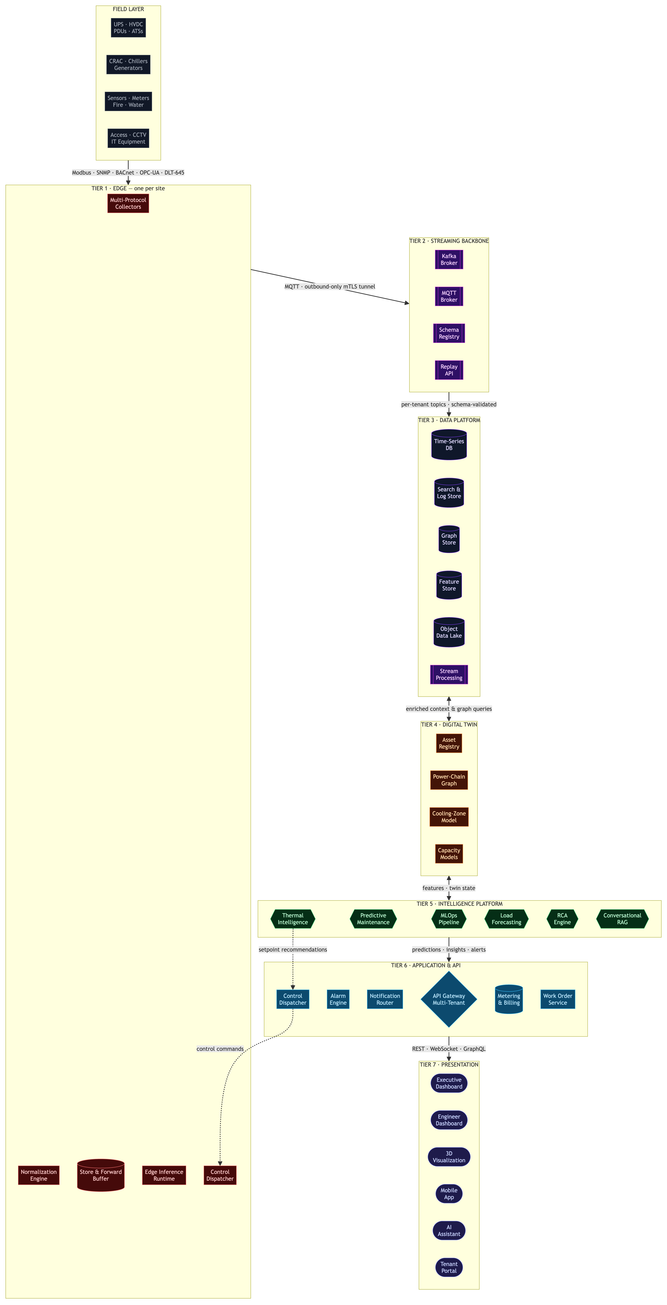
Diagram key: Stadium shapes ( ) = user-facing services · Hexagons { } = AI modules · Cylinders [( )] = data stores · Double-border [[ ]] = streaming components · Diamond { } = gateway · Solid arrows = data flow · Dashed arrows = control/command flow

2.1.1 Digital Twin — Dependency Graph
This graph is what lets the system reason about cause and effect instead of just listing alarms side by side. Each asset is a node. The power and cooling relationships between them are the edges. When something fails, we walk the graph to find what caused it and everything downstream that’s now at risk.
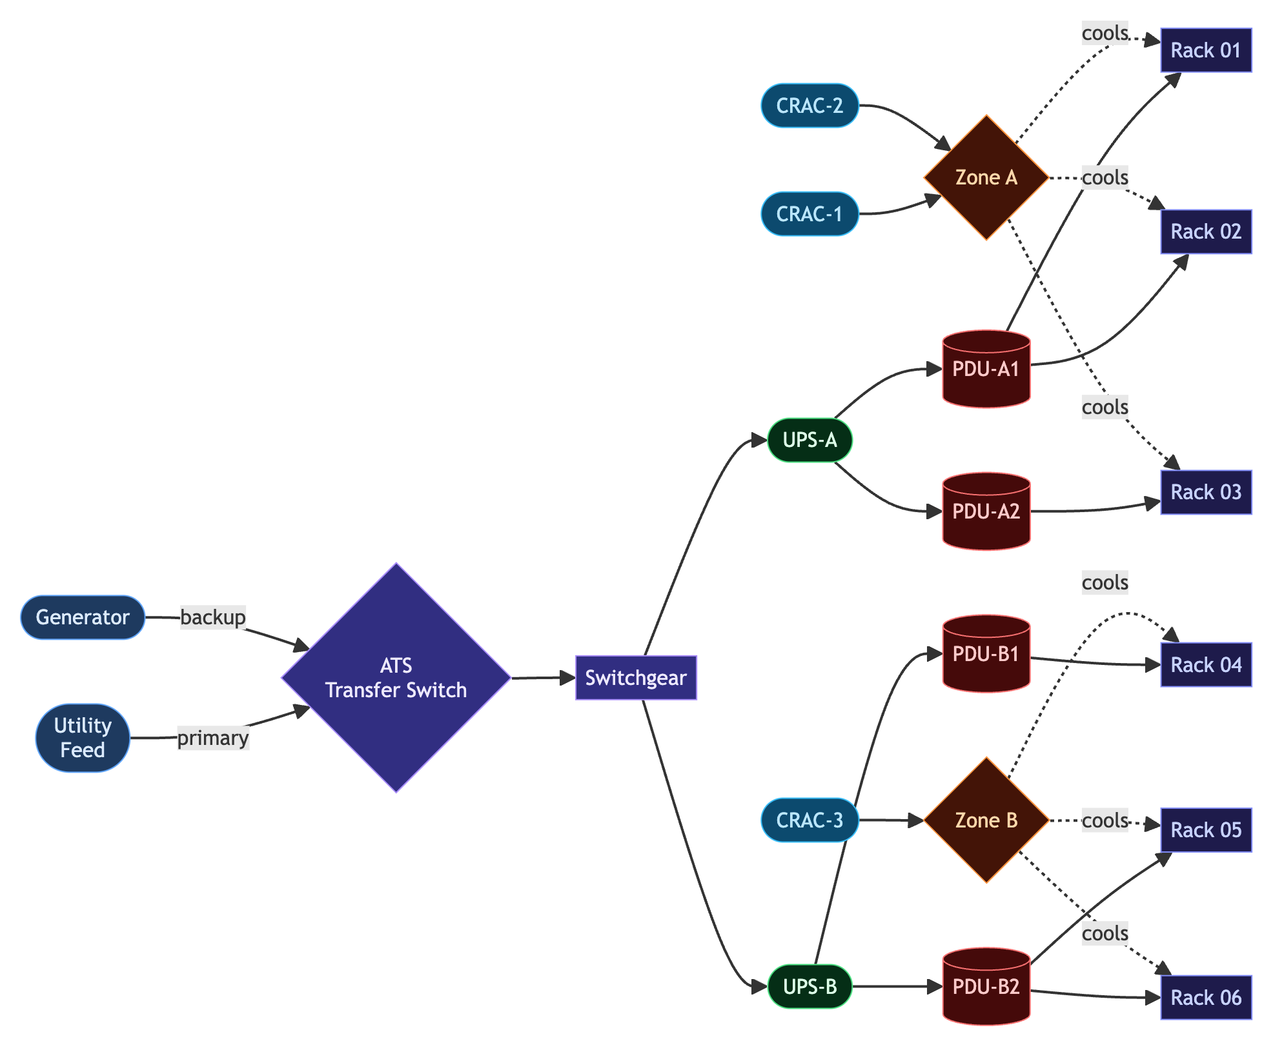
A worked example. Rack 04 raises a thermal alarm. The engine follows the cooling edges back to Zone B and CRAC-3 and checks whether CRAC-3 is faulting. In parallel, it follows the power edges back through PDU-B1 to UPS-B. The graph identifies the likely cause, and the LLM presents it as a plain-language summary the on-call engineer can act on immediately, without cross-referencing several screens.

2.2 Tier Design Rationale
Tier | Responsibility | Key Design Decision
1 — Edge | Per-site industrial gateway. Acquires all protocols, normalizes to canonical schema, buffers data locally, runs latency-critical inference offline. | Edge must be fully autonomous during WAN loss. Dual NIC isolates OT from IT. All control commands are translated here to device-native writes.
2 — Streaming Backbone | MQTT (edge-to-broker, lightweight for unreliable WAN) into Kafka-class broker. Schema registry enforces canonical model on every message. | Streaming backbone decouples every tier and provides durable replay — new models can train against full history, new sites can backfill on first connect.
3 — Data Platform | Several stores, each doing what it’s good at: a time-series DB for telemetry, a search/log store for events, a graph store for the dependency model, a feature store for ML, and an object lake for archives. | One database cannot serve all of this well. ML needs months of history and stable features; operators need sub-second queries. Those requirements pull in different directions.
4 — Digital Twin | Live, relationship-aware model of every facility. Power chain and cooling zones modeled as a graph, bound to real-time telemetry. | The dependency graph is what makes root-cause analysis and impact analysis possible — it is how the system knows a PDU fault can cause a downstream CRAC alarm.
5 — Intelligence | MLOps pipeline: train, register, deploy, monitor, retrain. RCA engine combines graph traversal with an LLM. RAG assistant grounded in the twin. | Built like production software, with versioning, drift monitoring and A/B checks, not a set of ad-hoc scripts. This is the part competitors cannot easily copy.
6 — Application | Multi-tenant API gateway, alarm engine, notification routing, control dispatch, work orders, metering, billing, audit. | Metering and billing are enforced in software here — subscription and per-device revenue streams require this tier to function correctly before commercial launch.
7 — Presentation | Persona-specific dashboards, 2D/3D visualization, mobile app, conversational assistant, tenant portal. | Different audiences need different views of the same truth. The conversational assistant is grounded in the live twin — every answer cites a live telemetry point or twin attribute, so it does not surface ungrounded device states.

2.3 Key Technical Decisions
Some of these we’ve locked. A few we’re deliberately leaving open until we’ve seen real data from the pilot. We’d rather pick the time-series database once we know the actual ingest rate than guess now and rebuild it in Phase 4.
Decision | Choice | Rationale
Time-series store | Evaluate TimescaleDB vs. VictoriaMetrics vs. InfluxDB against expected ingest rate before Phase 1 exit | All three are mature OSS; selection depends on cardinality, retention, and query patterns at pilot scale
Graph store for dependency model | Evaluate PostgreSQL + AGE vs. dedicated graph DB | Graph queries for RCA and impact analysis are fundamental; flat tables cannot model the power chain efficiently
ML serving framework | Evaluate MLflow + BentoML vs. Ray Serve | Depends on model update frequency and inference latency requirements; decided in Phase 3
LLM provider | Claude API (Anthropic) for RCA narratives and conversational assistant | Strong reasoning, long context for telemetry, enterprise API with data privacy guarantees
Edge runtime | Docker on industrial ARM gateway (fanless, dual NIC) | Containerized stack makes edge updates identical to cloud deployments; ARM is low-power
Frontend framework | React + TypeScript with WebSocket-driven live data | Persona dashboards require real-time updates; WebSocket over REST for telemetry views

3. Deployment Options
One codebase, four ways to deploy it. The edge tier is identical in every case; what changes is where the processing and analytics run. Most clients will choose SaaS. The other three options exist because banks, government, and critical-national-infrastructure clients in this region often cannot use anything else, and it is far easier to win that work when the option is already built in.
Topology | Architecture | Target Client | Trade-offs
SaaS (default) | hosted multi-tenant cloud. Edge gateways establish outbound mTLS tunnels. Clients access via web/mobile. | Standard commercial, telecom, colocation operators | The fastest to onboard and the least effort for the client to run, and the best economics for, provided WAN latency is acceptable.
On-Premises | Full platform stack deployed inside the client’s own data center infrastructure. No cloud dependency after installation. | Banks, government, classified sites, hypersensitive regulated clients | Maximum data sovereignty, at the cost of more deployment effort. delivers and maintains it on site.
Hybrid | Edge acquisition + AI inference run locally at the site. Aggregated analytics, dashboards, and cross-site views are cloud-hosted. | High-security sites that have connectivity but cannot send raw telemetry to cloud | A balance between sovereignty and managed-service economics. Because inference runs locally, safety-critical decisions never depend on the cloud being reachable.
Air-Gapped | Entire stack deployed on isolated infrastructure with no internet connectivity whatsoever. Updates delivered physically. | Military, critical national infrastructure | The highest security posture, but with substantially more support overhead. It applies to only a small subset of clients.

Deployment Decision Flow
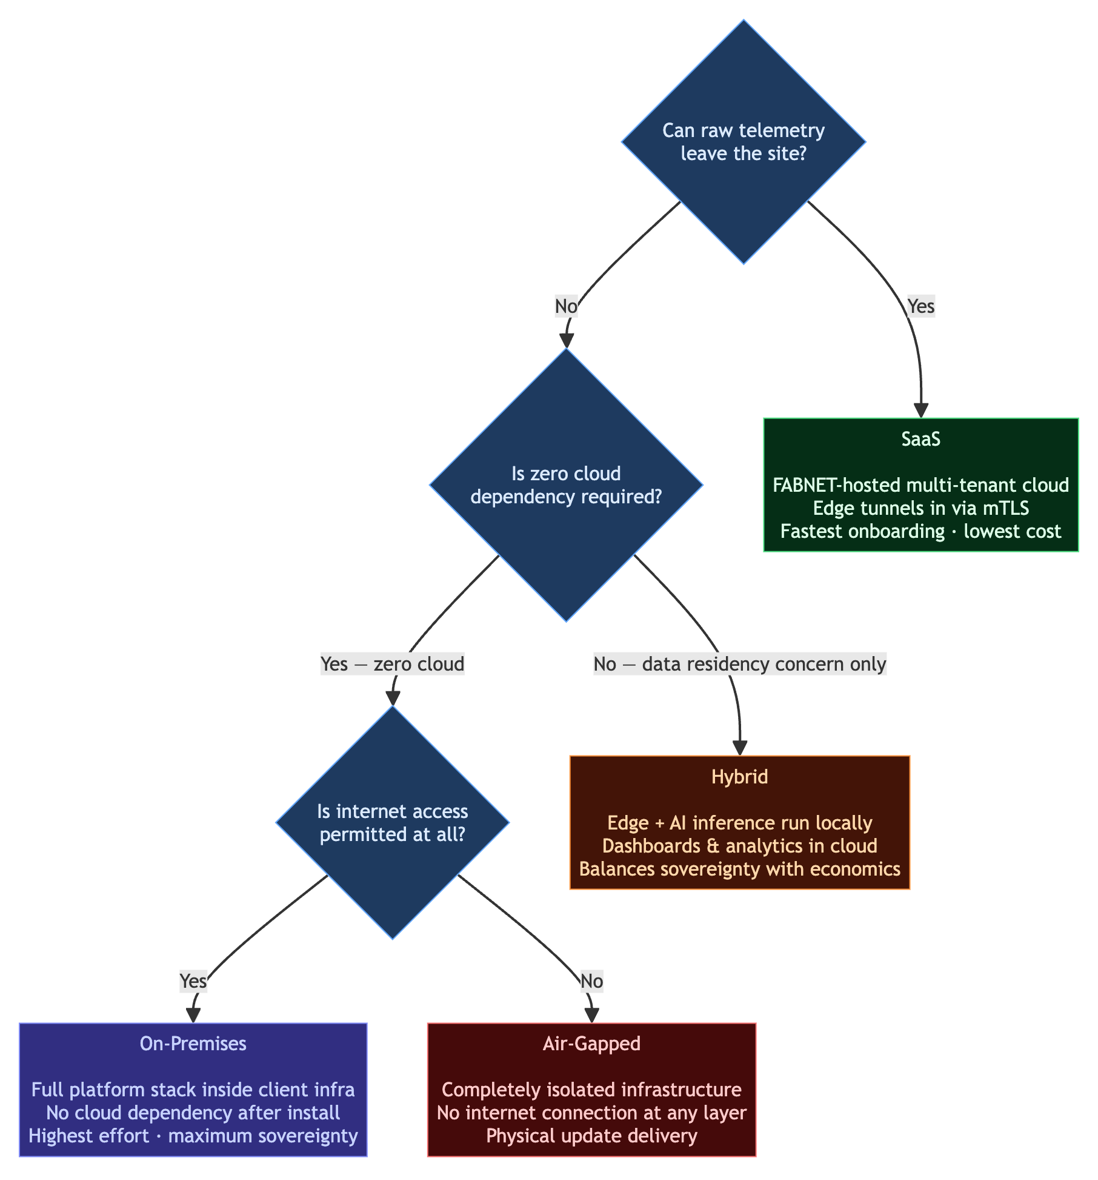

4. Team
We’ll run this with 11 people for the full 14 months: one lead architect, seven engineers, and three QA. We run two frontend engineers rather than one, deliberately: the user-facing surface — persona dashboards, 2D/3D visualization, the drag-and-drop dashboard builder, and the React Native mobile app — is the single broadest part of the product, and a lone frontend engineer would be a single point of failure across a large share of it. Splitting it (one engineer owns web dashboards, the other owns 3D and mobile) keeps the work parallelized and means either can cover the other. QA starts in week one rather than at the end. On OT projects the field data is consistently messier than the datasheets suggest, and multi-tenant isolation issues tend to surface late, close to go-live, so we test continuously throughout the build. Three QA also lets us separate the three testing concerns that otherwise get skipped under pressure: functional correctness, automated performance at scale, and security.
Role | Count | Months Active | Phases | Responsibility
Solution Architect / Technical Lead | 1 | 1–14 | All | End-to-end technical leadership; architecture design; DevOps/CI-CD oversight; cross-team alignment
Engineer — Edge & OT Gateway | 1 | 1–14 | All | Protocol adapters, edge collector stack, OT/IT dual-NIC segregation, edge store-and-forward, write adapter execution
Engineer — Data Platform & SRE | 1 | 1–14 | All | Runs the databases (PostgreSQL, TimescaleDB, pgvector, graph store), the Kafka/MQTT brokers, and the Helm charts
Engineer — Backend & Digital Twin | 1 | 1–14 | All | Core microservices, API Gateway, multi-tenant routing, digital twin asset registry and graph model queries, billing integration
Engineer — Backend & Integration | 1 | 1–14 | All | Alarm rules engine, notification router, SSO, work order management service, webhooks & enterprise ITSM/BMS connectors
Engineer — AI / ML | 1 | 1–14 | All | MLOps pipelines, predictive models, thermal forecasting, causal Bayesian RCA engine, LLM narratives & RAG assistant
Engineer — Frontend & Mobile (Web & Dashboards) | 1 | 1–14 | All | Operator/Engineer/Executive dashboards, 2D floor plans, custom drag-and-drop dashboard builder, data visualization, accessibility
Engineer — Frontend & Mobile (3D & Mobile) | 1 | 1–14 | All | Interactive 3D WebGL room rendering, thermal/power overlays, React Native iOS/Android app, push notifications, offline sync
QA Engineer — Functional & Data Quality | 1 | 1–14 | All | Functional & integration testing, telemetry data-quality validation, acceptance testing against DEMS parity
QA Engineer — Automation & Performance | 1 | 1–14 | All | Automated regression suites, CI test infrastructure, load and scale testing, billing-accuracy test harness
QA / Security Engineer — Isolation & Pen Test | 1 | 1–14 | All | Multi-tenant isolation testing, security & penetration testing, audit-log verification, compliance validation
Total | 11 FTE | 14 months

Focus Profile
The work runs in parallel streams rather than a single line, and we balance the load deliberately so a phase never leaves some people idle while another person is overloaded. The heaviest single concentration is the AI/ML engineer across Phases 4 and 5, when the whole intelligence layer lands. The Backend & Integration engineer, whose own load is lighter once the core services and enterprise connectors are built, backs that stream on model serving and integration.
Phases 1–2 (M1–5): Edge/OT and Data/SRE build the telemetry and ingestion backbone. The two
frontend engineers and Backend & Digital Twin implement the dashboards and
DEMS parity; Backend & Integration, lighter here, supports edge and platform
tooling. The AI engineer profiles data quality and stands up the feature store.
Phases 3–4 (M5–10): Edge/OT and Backend build the control writebacks and safety playbooks. The AI
engineer, backed by Data/SRE on the graph and by Backend & Integration on model
serving, trains the predictive and forecasting models. Frontend splits across
control UIs (web) and 3D thermal maps (3D and mobile).
Phases 5–6 (M10–14): The AI engineer leads causal RCA and the LLM assistant, with Backend on
enterprise integrations. Data/SRE and both frontend engineers package the
on-prem, hybrid, and air-gapped bundles and run the launch.

5. Development Plan
We’ve structured the program so that every phase ends with something you can deploy and bill for. The first invoice does not wait until the end of the project; it comes around month five, when the monitoring platform goes live and the first client begins paying. Each phase after that adds a tier you can charge for. No phase is pure investment with nothing to show for it.

5.1 Program Overview
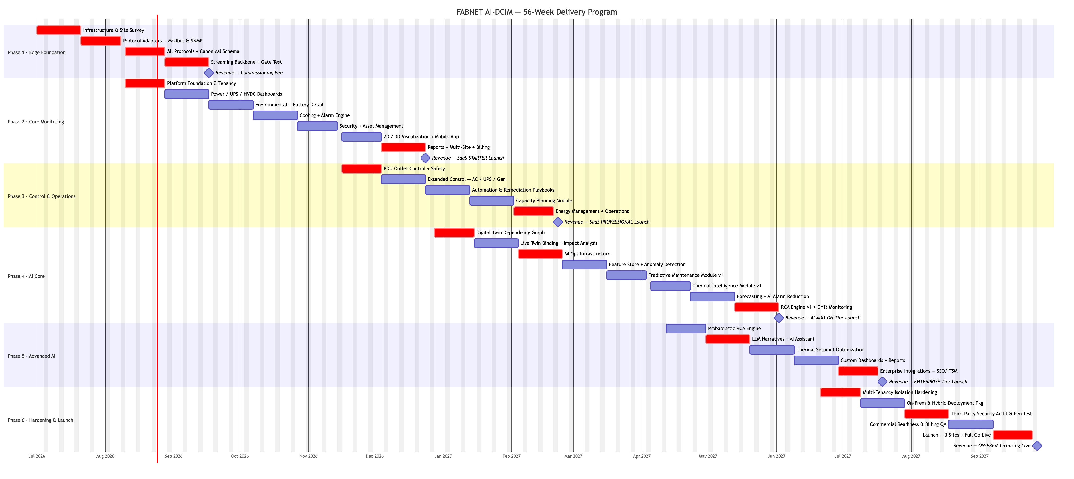

5.2 Phase Summary Table
One thing to read carefully in the table: the week ranges overlap. Phase 2 starts while Phase 1 is still closing out, and so on. That is deliberate. Each row also names the gate that has to be met to leave the phase and the revenue it unlocks.
Phase | Period | Weeks | Team (FTE) | Gate | Revenue Unlock
1 — Edge Foundation | M1–M2 | 1–8 | 11 | Zero-loss telemetry over 14-day window + WAN recovery test | Hardware commissioning fee
2 — Core Monitoring | M2–M5 | 7–20 | 11 | All DEMS-equivalent features live, first paying client | SaaS Starter subscription
3 — Control & Operations | M5–M7 | 19–28 | 11 | PDU control + capacity planning validated at pilot site | SaaS Professional tier
4 — AI Core | M7–M10 | 25–40 | 11 | PM + Thermal + Forecasting + Noise Reduction in production, gate KPIs met | AI Add-on tier
5 — Advanced AI | M10–M12 | 39–48 | 11 | Probabilistic RCA + assistant live, PUE reduction demonstrated | Enterprise tier + managed services
6 — Hardening & Launch | M12–M14 | 47–56 | 11 | ≥3 sites live, security audit passed, on-prem package validated | On-prem licensing + full commercial launch

Phase 1: Edge Foundation
Duration: Weeks 1–8 (Months 1–2) | Team: 11 FTE

Team Allocation
Role | Sprint Focus
Solution Architect / Tech Lead | Architecture decisions, protocol strategy, canonical schema design, CI/CD & cloud Kubernetes oversight
Engineer — Edge & OT Gateway | Industrial gateway OS base image, dual-NIC OT/IT segregation, store-and-forward local buffering, Modbus/SNMP/BACnet/OPC-UA/DLT-645 protocol adapters
Engineer — Data Platform & SRE | Schema registry deployment, Kafka cluster and MQTT broker provisioning, initial database clustering (relational & time-series)
Engineer — Backend & Digital Twin | Core API gateway scaffolding, token-based authentication configuration (JWT), base RBAC, secrets management
Engineer — Backend & Integration | Notification router scaffolding, webhook trigger system
Engineer — AI / ML | Telemetry data-quality profiling, feature engineering pipeline design, feature store setup
Engineer — Frontend & Mobile (Web & Dashboards) | Dev environment, raw data-stream visualization dashboard, design system & component library bootstrap
Engineer — Frontend & Mobile (3D & Mobile) | Mobile app framework bootstrapping, 3D rendering tooling evaluation and spike
QA Engineer — Functional & Data Quality | Site-survey validation, telemetry data-quality test harness, telemetry ingest verification
QA Engineer — Automation & Performance | WAN-outage / zero-loss simulation test automation, ingest throughput baselining
QA / Security Engineer — Isolation & Pen Test | mTLS tunnel and OT-segregation security validation

Sprint Breakdown
Sprint | Weeks | Deliverables | Done When
S1.1 — Infrastructure & Site Survey | 1–2 | Dev environment + CI/CD pipeline live · Cloud Kubernetes cluster provisioned · Edge hardware selected and ordered · Pilot site survey completed (device inventory, protocols, network topology, OT/IT layout) | All team members can deploy to dev; site survey report delivered
S1.2 — First Protocol Adapters | 3–4 | Edge gateway OS base image (Linux ARM, containerized) · Modbus TCP adapter (PDUs, CRAC) · Modbus RTU/RS485 adapter (legacy sensors) · SNMP v1/v2c/v3 adapter (UPS, network gear) · First live readings from UPS and PDU flowing end-to-end | UPS load%, battery voltage, and PDU current visible in raw data stream
S1.3 — All Protocols + Schema | 5–6 | DLT-645 adapter (smart meters) · BACnet adapter (building automation) · OPC-UA adapter (industrial controllers) · Proprietary protocol adapters for known device library · Canonical telemetry schema v1 (assetId, metric, value, unit, qualityFlag, timestamp) · Schema registry deployed and enforcing schema on every message | All field device classes (UPS, HVDC, CRAC, PDU, sensors, access, fire) streaming normalized data
S1.4 — Backbone + Resilience | 7–8 | MQTT broker at edge · Kafka cluster in cloud · MQTT→Kafka connector with dead-letter handling · Store-and-forward buffer (edge persists data during WAN loss, drains on reconnect) · Outbound-only mTLS tunnel (no inbound OT exposure) · Dual-NIC OT/IT segregation on gateway · WAN outage simulation test (2-hour disconnect, verify zero data loss) · 14-day monitoring window initiated | WAN recovery test passes; data continuity confirmed; 14-day window running

Exit Gate
All device classes streaming to cloud with no data loss (within the edge buffer’s retention window) across 14 consecutive days, including at least one simulated WAN outage recovery.

Phase Risks
Risk | Mitigation
Edge hardware delayed (supply chain) | Order in Week 1; run protocol adapters on dev VM in parallel using device simulators
Undocumented proprietary protocols on site | Allocate 1 week buffer in S1.3 for protocol reverse-engineering; start with documented protocols first
OT network access restricted by pilot client | Negotiate network access agreement before site survey; include in project kickoff checklist

Commercial Milestone
invoices the pilot client for site survey and hardware commissioning (one-time). No subscription revenue yet.

Phase 2: Core Monitoring Platform (DEMS Replacement)
Duration: Weeks 7–20 (Months 2–5) | Team: 11 FTE

Team Allocation
Role | Sprint Focus
Solution Architect / Tech Lead | Platform design review, API contracts, feature gating, staging/prod environment oversight
Engineer — Edge & OT Gateway | Protocol adapter refinements based on live field tests, local offline buffering logic updates, edge diagnostics
Engineer — Data Platform & SRE | Relational database schema, asset registry model, U-position database tables, time-series data retention and archival policies
Engineer — Backend & Digital Twin | Multi-tenant tenant-isolation routing, asset registry CRUD APIs, Stripe billing integration, floor plan database models
Engineer — Backend & Integration | Alarm rules engine v1, email/SMS notification routing, work order management APIs, event logs
Engineer — AI / ML | Alarm-correlation heuristic logic, telemetry historical data curation, baseline training data labelling
Engineer — Frontend & Mobile (Web & Dashboards) | Operator, Engineer, and Executive dashboards, 2D floor plans with live heat maps
Engineer — Frontend & Mobile (3D & Mobile) | Interactive 3D WebGL room views, mobile alarm app (query, acknowledge, real-time status)
QA Engineer — Functional & Data Quality | Functional verification against DEMS parity, dashboard telemetry accuracy audits, report generation QA
QA Engineer — Automation & Performance | Automated regression suite for dashboards, scale test for 1,000 parallel streams
QA / Security Engineer — Isolation & Pen Test | Multi-tenant data-isolation pen-tests, RBAC role-privilege bypass tests

Sprint Breakdown
Sprint | Weeks | Deliverables | Done When
S2.1 — Platform Foundation | 7–8 | Multi-tenant data model · Tenant management API (create, configure, isolate) · API gateway (Kong/Traefik) with JWT + OAuth2 auth · Per-tenant Kafka topic isolation · Frontend project scaffold (React + TypeScript) · Design system and component library bootstrapped | New tenant can be provisioned and their data is strictly isolated
S2.2 — Power Dashboards | 9–10 | Dynamic power distribution topology diagram (auto-drawn from device data) · Per-circuit breaker status with live current readings · UPS detailed view: load%, input/output V&Hz, bypass status, runtime remaining · HVDC monitoring dashboard · Historical trend charts for all power metrics | engineer can monitor all power equipment from a single view
S2.3 — Environmental + Battery | 11–12 | Temp/humidity dashboard organized by cabinet row and aisle · Cold/hot aisle heat map (color-coded by current temperature vs. threshold) · Per-cell battery monitoring view (voltage, temperature per cell) · Battery discharge history with timeline chart · Alarm engine v1: configurable thresholds, 4-tier severity, deduplication | engineer can identify hot-aisle issues and battery degradation at a glance
S2.4 — Cooling + Alarm Management | 13–14 | Precision AC/CRAC detailed dashboard (fan speed, water valve %, compressor status, water loop temps) · Alarm convergence engine (parent alarm shown; downstream child alarms grouped and collapsed) · SMS + email notification routing with per-alarm-type rules · Alarm acknowledgement workflow (assign to engineer, add notes, resolve) · Alarm escalation chains (auto-escalate unacknowledged alarms after configurable timeout) · Alarm history with full audit trail | Operations team can manage the full alarm lifecycle without leaving the platform
S2.5 — Security + Asset Management | 15–16 | Access control management (personnel records, schedule-based access, privilege cards) · Security & fire floor-plan overlay (real-time door/smoke/water leakage/camera status) · CCTV live feed viewer + alarm-triggered clip retrieval · U-position asset tracking (idle/occupied/reserved/pre-allocated) · Equipment attributes log (make, model, serial, install date) · Spare parts inventory with low-stock alerts | Security and physical access events visible on the platform; assets tracked to the rack unit
S2.6 — 2D/3D Visualization + Mobile | 17–18 | 2D floor plan editor (drag-and-drop device placement, import JPG/PNG) · Interactive 3D room view (real-time device status, alert animations, click-to-detail) · Mobile app iOS + Android (alarm query, acknowledge, real-time status, historical data) · Round inspection workflow (checklist-driven mobile walk-through) · Shift handover report generator (auto-summary of events during the shift) | Operators can use mobile for full alarm management; 3D view is live with real device states
S2.7 — Reports + Multi-Site + Billing | 19–20 | Data query engine (alarm, device, historical, cross-device linked queries) · XLSX/CSV/PDF export for all report types · Multi-site overview dashboard (geographic map + list view with per-site status roll-up) · Basic work order management (create, assign, schedule, close) · Usage metering + per-site subscription billing (Stripe or custom billing integration) · Gate review with team | First client paying a monthly subscription; billing system tracking per-site usage accurately

Exit Gate
≥3 engineers using the platform as their primary monitoring tool for ≥2 weeks. First paying client subscribed and billed. DEMS-equivalent feature parity confirmed by the client to sign-off.

Phase Risks
Risk | Mitigation
3D visualization performance on large sites | Use LOD (level of detail) rendering; test with real device counts early in S2.6
Mobile app store approval delays | Submit to Apple/Google stores at S2.6 start (2–4 week approval buffer)
Client reluctant to migrate from DEMS | Run parallel operation (DEMS + new platform) for 30 days; new platform must pass a side-by-side parity review

Commercial Milestone
SaaS Starter tier live. Per-site monthly subscription billing. Target: 2–3 pilot clients converted. Starter tier includes: monitoring, alarms, asset management, 2D/3D visualization, mobile.

Phase 3: Control & Operations Layer
Duration: Weeks 19–28 (Months 5–7) | Team: 11 FTE

Team Allocation
Role | Sprint Focus
Solution Architect / Tech Lead | Control safety architecture, capacity model design
Engineer — Edge & OT Gateway | Device write adapters (PDU SNMP SET, Modbus coil writes, AC setpoint push), local hardware lockouts & safety PLC verification
Engineer — Data Platform & SRE | Power-chain dependency data tables, cooling zone relationship schema, capacity tracking queries, network port documentation
Engineer — Backend & Digital Twin | Control dispatcher service, playbooks execution APIs, capacity planning API endpoints
Engineer — Backend & Integration | Playbook event-trigger engine, automated load shedding orchestrator, preventive maintenance schedule engine
Engineer — AI / ML | Energy efficiency analytics models, load forecasting model prototyping, baseline database for predictive models
Engineer — Frontend & Mobile (Web & Dashboards) | Control UI (double-confirmation panels), capacity planning dashboards, PUE/carbon trend screens
Engineer — Frontend & Mobile (3D & Mobile) | 3D capacity/thermal overlays, mobile checklists and control actions
QA Engineer — Functional & Data Quality | Control writeback safety validation, capacity headroom mathematical check vs manual calculations, energy report auditing
QA Engineer — Automation & Performance | Automated regression for control flows, playbook dry-run test harness
QA / Security Engineer — Isolation & Pen Test | Control-action audit-log verification, penetration testing of write endpoints

Sprint Breakdown
Sprint | Weeks | Deliverables | Done When
S3.1 — PDU Control + Safety | 19–20 | Control dispatcher service (translates platform command → device-native write via edge) · Smart PDU outlet on/off/reboot per outlet · Mandatory confirmation dialog + approval gate for destructive actions · Control audit log (immutable: user, action, target device, timestamp, result) · Safety interlocks (prevent shutdown of outlets serving critical loads) · Access lock/unlock remote override | Engineer can power-cycle a specific PDU outlet from the platform; every action is logged and traced
S3.2 — Extended Control | 21–22 | AC setpoint remote push (precision AC units via Modbus write) · UPS bypass/transfer mode command · Generator remote start/stop (with confirmation + dry-run mode) · ATS manual source transfer · IT equipment monitoring (IPMI, iLO, iDRAC — server power draw, CPU/memory) · Generator + ATS dedicated monitoring dashboards | Full active control suite operational; IT equipment metrics visible
S3.3 — Automation + Remediation | 23–24 | Visual playbook builder: drag-and-drop event → condition → action designer · Playbook test/dry-run mode (simulates execution without writing to devices) · Pre-built playbook templates: “Load shedding on UPS low battery”, “Lock down on fire alarm” · Load shedding priority tier configuration · Scheduled power cycling (define maintenance window → auto-execute) · Ventilation/lighting control integration | Operator can create and test an automation playbook without writing code
S3.4 — Capacity Planning | 25–26 | Power capacity model per PDU/UPS/site (available vs. allocated vs. measured) · Cooling capacity model (available headroom per CRAC zone) · Rack space capacity with visual rack elevation and U-position fill-rate · What-if planning simulator (“add 5 kW to Zone B — show impact on power and cooling headroom”) · Decommissioning workflow with upstream/downstream impact preview · Network port capacity (patch panel and switch port tracking) | Capacity planner can simulate a new deployment before any physical change is made
S3.5 — Energy + Operations | 27–28 | Live PUE per site and per zone (updated every 60 seconds) · Energy consumption drill-down: site → zone → rack → outlet · Tariff-based energy cost calculations (time-of-use rate tables) · Cost allocation by tenant or department · Carbon footprint reporting (kg CO₂ equivalent per kWh × grid factor) · Preventive maintenance schedule builder (asset class + recurring interval) · SLA tracking and reporting (response time, resolution time vs. committed levels) · Professional tier billing activated | Professional tier clients can see their energy spend and manage maintenance schedules from the platform

Exit Gate
PDU outlet control, AC setpoint push, and at least one automated remediation playbook confirmed working at pilot site. Capacity planning module shows validated power and cooling headroom matching engineers’ manual calculations within ±5%.

Phase Risks
Risk | Mitigation
Device write commands rejected by firmware | Test write capability in S3.1 before building full UI; maintain a per-device-model capability registry
Accidental shutdown of production loads | Mandatory double-confirmation for any outlet OFF command; critical-load flag prevents control action entirely
Capacity model diverges from reality | Validate model output against physical measurements at the pilot site before exposing to clients

Commercial Milestone
SaaS Professional tier live. Starter clients upgrade. Professional tier adds: remote control, automation playbooks, capacity planning, energy management, preventive maintenance.

Phase 4: AI Core
Duration: Weeks 25–40 (Months 7–10) | Team: 11 FTE > Requires ≥90 days of clean, continuous history from Phase 1–2 operations before ML models are trained.

Team Allocation
Role | Sprint Focus
Solution Architect / Tech Lead | MLOps architecture, graph schema design, AI feature gating, GPU/serving infra oversight
Engineer — Edge & OT Gateway | Local edge ML model inference packaging, telemetry stream feature ingestion at edge
Engineer — Data Platform & SRE | Graph database setup (e.g. Apache AGE / pgrouting), digital twin dependency model populate, live telemetry twin binding
Engineer — Backend & Digital Twin | RCA API endpoints, dependency graph traversal services, live twin telemetry syncer
Engineer — Backend & Integration | Alarm suppression service integration, predictive alert webhooks, model endpoints API gateway integration
Engineer — AI / ML | Model training: Predictive maintenance (RUL models for batteries/fans), Thermal hotspot forecasting, Time-series load forecasting, AI alarm suppression
Engineer — Frontend & Mobile (Web & Dashboards) | AI prediction widgets, RCA path visualization, anomaly & forecast dashboards
Engineer — Frontend & Mobile (3D & Mobile) | Predictive thermal 3D maps, mobile predictive-maintenance alert push
QA Engineer — Functional & Data Quality | ML model accuracy evaluation against validation sets, baseline data-quality gate validations
QA Engineer — Automation & Performance | ML inference latency and throughput scaling checks, drift-monitoring validation
QA / Security Engineer — Isolation & Pen Test | GPU training-infrastructure security audits, model-endpoint access control tests

Sprint Breakdown
Sprint | Weeks | Deliverables | Done When
S4.1 — Digital Twin Graph | 25–26 | Graph store schema (nodes: assets; edges: powers, cools, feeds) · Bulk import tool (populates graph from existing asset registry + floor plan data) · Power-chain graph: utility → ATS → switchgear → UPS → PDU → outlet → rack · Graph traversal API (upstream/downstream queries) · Impact analysis: “If UPS-2 fails, which racks lose power?” | Dependency graph fully populated and returning correct impact analysis results for the pilot facility
S4.2 — Live Twin + Cooling Graph | 27–28 | Cooling-zone dependency model (CRAC unit → zone → rack rows) · Live binding: each graph node bound to its real-time telemetry stream · Twin health monitor: alerts when an asset loses its telemetry binding · Twin change history: every topology modification versioned and reversible · Twin completeness score: % of assets fully modeled and bound | Digital twin reflects current physical state; impact analysis uses live telemetry
S4.3 — MLOps Infrastructure | 29–30 | Training cluster provisioned (GPU-enabled for deep learning models) · Model registry (MLflow) with versioning, tagging, and artifact storage · Versioned serving endpoints (models deployed as REST APIs behind the model registry) · A/B evaluation framework (challenger model vs. champion model comparison) · Performance monitoring dashboards (accuracy, latency, throughput per model) | ML team can train, register, deploy, and compare models without manual infrastructure steps
S4.4 — Feature Store + Anomaly Detection | 31–32 | Feature engineering pipeline (raw telemetry → engineered features per device class: rolling stats, rate-of-change, z-scores) · Feature store with point-in-time correct joins (training and live inference use identical features) · Statistical anomaly detection on all time-series (isolation forest + z-score ensemble) · Anomaly alerts routed into the alarm engine · Engineer labeling tool: annotate known failure events as ground truth for model training | Anomaly-based alerts firing on the pilot site; engineers labeling events to build training datasets
S4.5 — Predictive Maintenance v1 | 33–34 | UPS battery remaining-useful-life (RUL) regression model trained on battery discharge history · Battery anomaly detection (early degradation: voltage sag, charge rate decline) · Fan anomaly detection (motor current draw, speed deviation from baseline) · Compressor health model (vibration proxy via current pattern) · PM module UI: per-asset RUL gauge, failure probability trend, maintenance recommendation · Backtesting: model predictions vs. known historical failures | PM module predicting UPS battery replacement needs ≥14 days ahead with ≥75% precision on pilot data
S4.6 — Thermal Intelligence v1 | 35–36 | Rack inlet temperature forecasting model (predicts hotspot formation 30–60 minutes ahead) · Cooling imbalance detection (zones where CRAC load vs. heat load is mismatched) · Hot/cold aisle efficiency scoring · Thermal alert routing into alarm engine (predictive, not threshold) · Thermal module UI: predictive heat map overlay on 3D view, imbalance heatmap | Thermal module predicting at least one upcoming hotspot event before it crosses threshold on pilot data
S4.7 — Forecasting + AI Alarm Noise Reduction | 37–38 | Power load forecasting (Prophet + LSTM ensemble; 7/14/30-day horizons) · Cooling load forecasting (linked to power forecast) · Capacity-exhaustion date projections (when will this site run out of power/cooling headroom?) · AI alarm noise reduction model: learns cross-device event correlations to suppress non-actionable alarms · Noise reduction UI: alarm volume before vs. after, suppression ratio, suppressed-alarm log | Load forecasting showing ≤15% MAPE on pilot historical data; alarm volume visibly reduced for pilot operators
S4.8 — RCA v1 + Drift Monitoring | 39–40 | RCA engine v1: deterministic causal graph traversal (walks power/cooling graph from alarm → root cause) · RCA result display: visual path from root cause node to all affected downstream assets · Model drift monitoring: automated performance regression detection per model · Auto-retrain trigger: when drift exceeds threshold, new training job queued automatically · AI tier billing activated · Gate review: PM precision ≥75%, alarm noise reduction ≥50%, RCA surfaces the correct cause within its ranked output on ≥75% of curated historical incidents (power/cooling-chain causes) | AI tier live and billable; gate KPIs met and signed off

Exit Gate
All four AI modules (Predictive Maintenance, Thermal Intelligence, Load Forecasting, AI Alarm Noise Reduction) live in production with documented precision/recall baselines. RCA surfaces the correct cause within its ranked output on ≥75% of curated historical test incidents (limited to power/cooling-chain causes). Drift monitoring active on all models.

Phase Risks
Risk | Mitigation
Insufficient clean history for ML training | If data quality issues surface, extend Phase 1 data collection window before training begins; per-device-class data readiness gate before each model trains
PM model precision too low on first training | Use engineer-labeled failure events as ground truth; apply transfer learning from public UPS failure datasets; communicate to clients that models improve with more history
Thermal model complexity underestimated | Start with a simpler physics-informed model (Pearson correlation of CRAC load vs. rack temp); layer ML on top once baseline is validated
Graph population incomplete (assets not modeled) | Build completeness validator in S4.2; gate AI module activation per-site on minimum twin completeness (≥85%)

Commercial Milestone
AI Add-on tier launched as an optional module on top of Professional tier. Existing clients activate per site. New clients pitch: predictive failure prevention + energy optimization.

Phase 5: Advanced Intelligence & Assistant
Duration: Weeks 39–48 (Months 10–12) | Team: 11 FTE

Team Allocation
Role | Sprint Focus
Solution Architect / Tech Lead | LLM integration design, RAG grounding strategy, enterprise feature scope
Engineer — Edge & OT Gateway | Edge collector historical data vectorization, edge caching optimizations
Engineer — Data Platform & SRE | Vector database deployment (pgvector), digital twin state vectorizer for RAG context, historical incidents store
Engineer — Backend & Digital Twin | LLM/Claude API orchestration, enterprise billing portal integrations, twin query optimization
Engineer — Backend & Integration | Enterprise SSO (SAML/OIDC), ITSM webhooks (Jira, ServiceNow), notifications export
Engineer — AI / ML | Bayesian causal RCA model, Conversational RAG pipeline (Claude API prompt engineering & grounding), Thermal setpoint optimization model
Engineer — Frontend & Mobile (Web & Dashboards) | Custom dashboard builder (drag-and-drop widgets), advanced report views
Engineer — Frontend & Mobile (3D & Mobile) | RAG Assistant chat interface, mobile conversational layout
QA Engineer — Functional & Data Quality | LLM assistant accuracy testing, RAG hallucination checks, SLA tracking verification
QA Engineer — Automation & Performance | Automated benchmark-query suite for the assistant, vector-DB retrieval performance checks
QA / Security Engineer — Isolation & Pen Test | LLM prompt-injection testing, SSO/OIDC token validation, vector-DB access controls

Sprint Breakdown
Sprint | Weeks | Deliverables | Done When
S5.1 — Probabilistic RCA | 39–40 | Bayesian causal inference model over the dependency graph · Root cause ranking: top-3 probable causes with confidence scores · Evidence chain: which sensor readings support each hypothesis · RCA backtesting against labeled historical incidents · RCA accuracy target: correct cause ranked in the top-3 on ≥85%, and top-1 on ≥70%, of the labeled test set | Probabilistic RCA outperforming deterministic v1 on historical incident dataset
S5.2 — LLM Narratives + Assistant Foundation | 41–42 | LLM API integration (Claude API) · Incident narrative generation: given an RCA result, produce plain-language summary (what happened, why, what to do next) · Vector DB setup (embeddings of asset data, historical incidents, maintenance records) · RAG pipeline: query → retrieve relevant twin context → augment prompt → answer · Conversational assistant prototype: grounded text query interface | “What caused the 2am alarm?” returns a factually grounded plain-language narrative
S5.3 — Assistant Refinement + Thermal Optimization | 43–44 | Assistant refinement: live telemetry context injection, multi-turn conversation, safety guardrails (no hallucinated device states) · Thermal setpoint optimization model (recommends AC setpoints that minimize PUE while maintaining thermal safety margins) · Optimization recommendation queue: each recommendation shows projected kWh savings + risk level · Operator acceptance workflow: approve/reject recommendation with one click · PUE trend dashboard: before-vs-after optimization impact | Conversational assistant correctly answers ≥90% of a defined benchmark query set on pilot facility data; first PUE reduction recommendation accepted by engineer
S5.4 — Custom Dashboards + Advanced Reports | 45–46 | Custom dashboard builder: drag-and-drop widget system (any metric, any chart type, any time range) · Advanced report suite: capacity planning report, SLA compliance report, predictive maintenance forecast report, energy optimization impact report · Scheduled report delivery (auto-send PDF/XLSX by email on a schedule) · Report template library | Engineer can build a new dashboard view in under 5 minutes without developer involvement
S5.5 — Enterprise Integrations + Portal | 47–48 | SSO integration (SAML 2.0, OIDC, Active Directory, LDAP) · ITSM webhook integrations (ServiceNow, Jira, Slack, Teams, email — configurable per alarm type) · Tenant self-service portal (manage users, assign roles, download reports, view usage and invoices) · Full REST API documentation (OpenAPI/Swagger) published · Enterprise tier billing activated | Enterprise client can provision their own users and integrate alarms into their ticketing system without involvement

Exit Gate
Probabilistic RCA ranks the correct cause in its top-3 on ≥85% (and top-1 on ≥70%) of labeled test incidents. Conversational assistant answers grounded queries with no ungrounded device-state claims (every answer cites live telemetry or a twin attribute). Thermal optimization recommending setpoints that demonstrate measurable PUE improvement (≥3%) on the pilot site.

Phase Risks
Risk | Mitigation
LLM hallucinating device states | Strict RAG grounding: every assistant answer must cite a live telemetry data point or twin attribute; non-grounded answers are blocked
Thermal optimization recommendations rejected by operators | Frame as recommendations (not automated actions); show confidence and projected savings; require one-click human approval before any setpoint change
Vector DB relevance quality poor | Iterative embedding strategy evaluation; use hybrid search (vector + keyword); evaluate retrieval recall against test queries weekly during S5.2–5.3

Commercial Milestone
Enterprise tier launched. Full AI suite + conversational assistant + dedicated support SLA. Managed service retainer contracts for clients who want to operate the platform.

Phase 6: Hardening & Commercial Launch
Duration: Weeks 47–56 (Months 12–14) | Team: 11 FTE

Team Allocation
Role | Sprint Focus
Solution Architect / Tech Lead | Launch readiness review, on-prem architecture validation
Engineer — Edge & OT Gateway | Air-gapped edge install scripts, hardware stress-tests on gateway devices
Engineer — Data Platform & SRE | On-prem Kubernetes Helm charts, database replica setups, automated data migration/upgrade playbooks
Engineer — Backend & Digital Twin | Multi-tenancy rate-limiting controls, billing verification audits, twin synchronization schema updates, SSO access logs
Engineer — Backend & Integration | SSO access log audits, third-party webhook security, API gateway performance tuning
Engineer — AI / ML | Automated model retraining triggers, model drift dashboard validation, local LLM deployment tests
Engineer — Frontend & Mobile (Web & Dashboards) | Accessibility review (WCAG), frontend bundle performance optimization
Engineer — Frontend & Mobile (3D & Mobile) | Mobile app final store releases, 3D performance & LOD optimization
QA Engineer — Functional & Data Quality | Cross-site functional regression suite execution, multi-site staging acceptance tests
QA Engineer — Automation & Performance | Multi-site load and soak test execution, billing-accuracy automated test suite
QA / Security Engineer — Isolation & Pen Test | Security-firm audit coordination, penetration-test remediation, immutable audit-log verification

Sprint Breakdown
Sprint | Weeks | Deliverables | Done When
S6.1 — Multi-Tenancy Hardening | 47–48 | Adversarial tenancy isolation test suite (automated: can Tenant A query Tenant B’s data?) · Per-tenant resource quotas (API rate limits, storage caps, compute throttling) · Tenant onboarding automation (new client provisioned in under 10 minutes via self-service) · On-prem Helm charts for full platform stack (all tiers deployable into customer Kubernetes) | Zero tenancy isolation failures; automated test suite passes 100%
S6.2 — Deployment Packaging | 49–50 | On-prem deployment runbook (step-by-step, validated by test deployment on fresh infrastructure) · Hybrid deployment package (edge + local AI tier; cloud dashboards + analytics) · Air-gapped deployment playbook (no-internet operation, physical update procedures) · Upgrade/migration procedures (in-place upgrade from any version to latest) · Multi-site load test: simulate 20+ concurrent sites, 1M metrics/min sustained for 4 hours · Performance benchmarks published | Load test passed; on-prem deployment completed from scratch in under 4 hours following the runbook
S6.3 — Security Audit + Pen Test | 51–52 | Third-party penetration test commissioned and executed (external security firm) · Findings triage: P0/P1 issues remediated before launch; P2/P3 documented with timelines · Encryption audit (all data at rest AES-256, all data in transit TLS 1.3) · Secrets management review (no hardcoded credentials anywhere in codebase) · Immutable audit log validated (no deletion or modification possible by any user including admin) | Zero P0/P1 findings outstanding; penetration test report published; security posture documented
S6.4 — Commercial Readiness | 53–54 | Billing automation end-to-end QA (per-site and per-device metering accuracy ±0.1%) · All four tier feature gates tested (Starter/Professional/AI/Enterprise correctly enable/restrict features) · Client training materials: video walkthroughs per persona (operator, engineer, executive) · Support runbooks for all four tiers · SLA definitions finalized (response time commitments per severity level per tier) · On-prem licensing model (annual license + support contract terms) | Billing system billing test accounts correctly; training materials approved
S6.5 — Launch + Site Validation | 55–56 | ≥3 independent client sites fully operational on the platform · Final documentation published (admin guide, API reference, integration guide, user manual) · Launch event: platform demonstrated to client base · All four tiers (Starter/Professional/AI/Enterprise) open to new commercial clients · On-prem licensing model live · Managed service agreement templates signed with first MSP clients | 3 sites live, billing automated, security audit closed, full commercial launch complete

Exit Gate
≥3 client sites live and stable for ≥2 weeks. Security audit passed (zero P0/P1 open). SaaS metering billing clients correctly. On-prem deployment completed from runbook in ≤4 hours. Full documentation published.

Phase Risks
Risk | Mitigation
Penetration test uncovers major vulnerability | Allocate 2-week remediation buffer inside S6.3; do not launch until all P0/P1 findings closed
On-prem client infrastructure non-standard | Document minimum infrastructure requirements during S6.2; validate on at least 2 different customer environments
Billing accuracy errors | Automated billing QA test suite in S6.4 runs on synthetic usage data with known expected invoice amounts

Commercial Milestone
Full commercial launch across all tiers. On-prem annual licensing. Managed service retainer agreements.

5.3 Revenue & Milestone Timeline
The point of this table is to show that the model shifts from project revenue to recurring revenue early, and then keeps building. The one-time commissioning fee in Phase 1 covers the initial site work. From month five onward the income is recurring, and each new tier raises what an existing client pays rather than replacing it.
Milestone | Phase | Month | Revenue Type | Cumulative Model
Site survey + hardware commissioning | 1 | M2 | One-time fee per site | Project-based
SaaS Starter subscriptions begin | 2 | M5 | Recurring monthly per site | Recurring begins
SaaS Professional tier launched | 3 | M7 | Recurring monthly (~2× Starter) | MRR grows
AI Add-on tier activated | 4 | M10 | Recurring monthly (premium) | MRR grows
Enterprise tier + managed services | 5 | M12 | Recurring monthly + retainer | High-margin MRR
On-prem annual licensing | 6 | M14 | Annual license + support | ARR model begins

5.4 Team Focus by Phase
The team is a fixed 11 FTE for all 14 months (1 lead, 7 engineers, 3 QA). The team works concurrently across its domains, which is what allows the phases to overlap rather than run one after another. The two frontend engineers split the user-facing surface — one owns web dashboards, the other owns 3D and mobile — so no single person is a bottleneck or a point of failure for the largest part of the product.
M1–M2 (Phase 1): Edge/OT & Data/SRE engineers build raw data flow; Backend and Frontend/Mobile bootstrap web/API gateways; QA sets up telemetry test rigs.
M2–M5 (Phase 2): Backend and Frontend/Mobile team focuses entirely on core monitoring and DEMS feature parity. AI engineer establishes the feature store.
M5–M7 (Phase 3): Edge/OT & Backend implement active writeback control systems; AI engineer designs the forecasting engines. Frontend/Mobile builds energy views.
M7–M10 (Phase 4): AI + Data/SRE engineers focus on training predictive maintenance models and live twin binding. Frontend/Mobile builds interactive 3D thermal maps.
M10–M12 (Phase 5): AI engineer builds conversational RAG and causal RCA engines; Backend & Data/SRE engineers integrate enterprise SSO/ITSM APIs and vector DBs.
M12–M14 (Phase 6): Frontend/Mobile releases final launch builds; Data/SRE & Backend engineers package Helm charts for on-prem; QA and Security run audits.

6. Commitments & KPI Register
Every figure we commit to anywhere in this document is collected here, so none of it is buried in the prose. These are targets we validate at a defined gate, not guarantees made on day one. Figures marked Gate are hard pass/fail criteria for exiting a phase. Every AI-accuracy figure additionally depends on data quality and history, which Section 9 covers.

6.1 Delivery, Team & Timeline
Commitment | Target | Type | Condition / Dependency
Program duration | ≈14 nominal months (56-week program; phases overlap) | Plan | Prerequisites met on schedule (Section 7)
Team | Fixed 11 FTE (1 lead · 7 engineers · 3 QA; frontend staffed 2-deep to avoid a single point of failure) for the full program | Plan | Team stays staffed throughout
First revenue | Phase 2 exit, ≈Month 5 | Plan | A willing pilot client + signed commercial agreement
Sites live at commercial launch | ≥3 independent client sites | Gate (Ph6) | Client sites available and access granted
DEMS parity sign-off | 100% of DEMS-equivalent features, | Gate (Ph2) | reviewer availability
Engineer adoption | ≥3 engineers use platform as primary tool ≥2 weeks | Gate (Ph2) | Named engineers assigned

6.2 Data & Resilience
Commitment | Target | Type | Condition / Dependency
Telemetry continuity | No data loss within edge buffer retention (7-day default) over a 14-day window | Gate (Ph1) | Buffer sized to worst-case WAN outage; gateway itself healthy
WAN outage recovery | Full replay after ≥2-hour simulated disconnect | Gate (Ph1) | —
Clean history before ML training | ≥90 days continuous, quality-gated data per device class | Gate (Ph4 entry) | Data meets minimum quality thresholds
PUE refresh rate | Updated every ≤60 seconds | Target | Meter/telemetry availability

6.3 AI / ML Accuracy — targets, conditional on data
Commitment | Target | Type | Condition / Dependency
Predictive maintenance (UPS battery) | ≥14 days advance warning at ≥75% precision (on pilot data) | Gate (Ph4) | ≥90 days clean history + engineer-labeled failure events; improves with more data
Thermal hotspot prediction | Detect ≥1 upcoming hotspot 30–60 min ahead on pilot data | Gate (Ph4) | Sufficient sensor density in the zone
Load forecasting | ≤15% MAPE on pilot historical data | Gate (Ph4) | Representative load history
AI alarm noise reduction | ≥50% at launch, trending toward 60%+ with feedback | Gate (Ph4: ≥50%) | Labeled correlation feedback from operators
RCA (deterministic v1) | Correct cause within ranked output on ≥75% of curated historical incidents (power/cooling-chain causes only) | Gate (Ph4) | Dependency graph ≥85% complete for the site
RCA (probabilistic v2) | Correct cause in top-3 on ≥85%; top-1 on ≥70% (labeled test set) | Gate (Ph5) | Labeled historical incident set
Conversational assistant | ≥90% of a defined benchmark query set answered without factual error; no ungrounded device-state claims | Gate (Ph5) | Twin populated and live-bound
Thermal setpoint optimization | ≥3% PUE improvement demonstrated on pilot | Gate (Ph5) | Client permits setpoint changes; operator approves recommendations
Digital-twin completeness to activate AI per site | ≥85% assets modeled and bound | Gate (per site) | Client-provided asset data / access
Capacity model accuracy | Within ±5% manual calculations | Gate (Ph3) | Physical measurements available for validation

6.4 Platform Performance & Security
Commitment | Target | Type | Condition / Dependency
Sustained scale (load test) | 20+ concurrent sites, 1M metrics/min for 4 hours | Gate (Ph6) | Cloud resources provisioned for test
Tenant provisioning time | < 10 minutes (self-service) | Target | —
On-prem deployment time | < 4 hours from runbook on standard infra | Gate (Ph6) | Client infra meets published minimum spec
Custom dashboard build time | < 5 minutes, no developer involvement | Target | —
Billing metering accuracy | ±0.1% on synthetic usage test | Gate (Ph6) | —
Encryption | AES-256 at rest, TLS 1.3 in transit | Commitment | —
Security posture at launch | Zero P0/P1 penetration-test findings open | Gate (Ph6) | Third-party pen-test firm engaged (Section 7)

6.5 Commercial Targets
Commitment | Target | Type | Condition / Dependency
Pilot clients converted | 2–3 during Phase 2 | Target | led sales; outside ASAL control
Tier structure | Starter → Professional (~2× Starter) → AI Add-on → Enterprise; on-prem annual license | Plan | Pricing set by client

7. Prerequisites & Client Dependencies
The timeline and commitments above assume the following are provided by / the client. A delay in any prerequisite shifts the dependent phase; these are not ASAL deliverables.

7.1 Before Kickoff (blocks Phase 1)
- Confirmed pilot site(s), with device inventory, protocol list, and network/OT topology.
- OT network access and credentials, together with a signed network-access agreement for the site survey.
- Device documentation (SNMP MIBs, Modbus register maps, BACnet point lists), or hands-on device access where documentation is missing. Reverse-engineering is possible, but the time allowed for it is finite.
- Physical provisioning for the edge gateway: rack or DIN-rail space, power, and both OT and IT network drops.
- Firewall and egress rules permitting the outbound-only mTLS tunnel to the chosen cloud region.
- A deployment decision: cloud provider and region (for data residency), or on-prem infrastructure that meets the published minimum specification.

7.2 During the Build (per phase)
- Named engineers for validation, DEMS parity sign-off, capacity-model verification, and labeling of historical failure events as ground truth for the ML models.
- A historical DEMS data export, if one is available, to accelerate model training and backtesting.
- Representative equipment for control testing: at least one UPS, CRAC, or PDU on which write commands (setpoint, outlet, bypass) can be tested safely.
- A willing pilot client, with an executed commercial agreement, before Phase 2 revenue can begin.
- Documented security and compliance requirements (the Qatar data-sovereignty rules) and the named authority who signs off on them.

7.3 Third-Party & Commercial Dependencies
- Edge gateway hardware. ASAL specifies it; the client procures and funds it (see Out of Scope).
- A cloud hosting account and its fees for SaaS, or on-prem infrastructure for a self-hosted deployment.
- Apple and Google developer accounts for publishing the mobile app. Store approval is outside ASAL’s control, so we assume a two-to-four-week buffer.
- A third-party penetration-test firm, engaged and funded, for the Phase 6 security audit.
- LLM API access and budget (Claude API) for the RCA narratives and the assistant, or approval and infrastructure for a local, on-prem model.
- A billing and payment account (for example, Stripe) and its transaction fees.

8. Out of Scope
Being clear about what we are not doing matters as much as the scope itself, and it avoids difficult conversations later in the engagement. The following are explicitly excluded from this proposal. Any of them can be taken on separately, either as a change request or as its own engagement.
Physical infrastructure and field work - Supply, installation, repair, or maintenance of field devices (UPS, CRAC, chillers, PDUs, sensors, cameras). The platform integrates existing hardware; it does not provide it. - Electrical and mechanical works, cabling to devices, sensor installation, and facility or civil works. - Support for purely analog or manual equipment that exposes no digital interface, unless a sensor or gateway is added. That added hardware is itself out of scope.
Infrastructure and recurring costs - The edge gateway hardware cost (specified by ASAL, funded by the client). - Cloud hosting, compute, and storage fees, and WAN or internet connectivity, along with their recurring charges. - Commercial third-party licenses or usage beyond the open-source core: for example, LLM API consumption, payment-processor fees, or a specific commercial database if the client mandates one.
Operations and services - Round-the-clock operations and NOC staffing, and day-to-day operation of the platform. These form the separate Managed Service offering rather than this build. - Client-side training beyond the materials and sessions defined in Phase 6. - Large-scale migration of historical data from DEMS beyond one agreed export and import. Any bespoke ETL is scoped separately.
Assurances we are not making - No guarantee of zero downtime or zero equipment failure. The platform predicts problems and helps operators respond to them. It does not prevent every failure, and it does not assume operational liability for the client’s infrastructure. - No retroactive AI insight before sufficient history exists (see Section 9). - No regulatory certification or accreditation delivered by ASAL. The platform supports compliance through audit logs, data segregation, and encryption, but formal certification is led by the client. - No integrations beyond the named protocols (Modbus, SNMP, BACnet, OPC-UA, DLT-645, IEC 61850) and the named enterprise systems (SSO, ServiceNow, Jira, Slack, Teams). Anything additional or proprietary is a change request.

9. Assumptions & Expectation-Setting
The following assumptions underpin the plan. They are stated explicitly because, in our experience, projects of this nature are compromised more often by four factors than by any technical challenge: inadequate data quality, complex legacy integration, the lead time required before AI delivers measurable value, and unrealistic expectations of immediate results.
- AI value follows a curve, not a switch. The real value in Months 1–5 comes from monitoring, the digital twin, dashboards, alarms, and control, not from AI. The models begin to produce value only after roughly 90 days of clean data, and reach full accuracy over 6–12 months. Client expectations need to be set to this curve. “Instant AI” is neither achievable nor something we promise.
- Data quality is the single largest risk to the AI targets. Every figure in Section 6.3 assumes telemetry meets the minimum quality thresholds for its device class. Where data is noisy, sparse, or missing, both accuracy and the training timeline suffer, and the per-site AI activation gate may move out.
- “No data loss” is bounded by the edge buffer. Continuity holds within the buffer’s retention window (a 7-day default, sized per site). An outage longer than that window, or a failure of the gateway hardware itself, falls outside the guarantee.
- Legacy integration effort is variable. Undocumented or non-conforming devices add integration time. Phase 1 carries a buffer for this, but the buffer is finite, and a heavily non-standard estate may require a scope adjustment.
- The timeline assumes prerequisites are met on time. Client-side delays (site access, sign-offs, hardware procurement, commercial agreements) shift the dependent phases one for one. The phases overlap, and they assume the fixed eleven-person team stays staffed throughout.
- Revenue milestones depend on commercial activity. Converting pilot clients and signing agreements is responsibility. ASAL delivers the billable product increment, not the sales outcome.
- The competitive matrix in Section 1.11 describes the delivered end-state. Not every capability marked with a tick exists on day one; availability follows the phase plan.
- Control remains decision-support by default. Automated actions require operator approval. Ultimate safety rests with the client’s operational procedures and hardware interlocks, not with the platform’s recommendations.
- This proposal deliberately does not quote a headline uptime SLA. Platform availability depends on factors ASAL does not control: the WAN links, client infrastructure, power, and OT networks. A blanket figure such as “99.9%” would not be an honest commitment across those dependencies. Any availability SLA will be set per deployment, scoped to the components ASAL actually operates, and will exclude client-side dependencies explicitly. The edge tier keeps acquiring and buffering data even when the cloud or WAN is unavailable, so local continuity does not depend on end-to-end uptime.
- AI accuracy figures are pilot baselines, to be re-based per site. The Section 6.3 targets are validated on pilot and curated data. Each new site is re-baselined as its own data accumulates; a target met on the pilot is not automatically guaranteed at another site with different equipment or data quality.

ASAL Technology · wafaneh@asaltech.com · August 2026

